SIMATS ENGINEERING ASSESSMENT TOOL 01

COURSE NAME: Ethical Hacking COURSE CODE: ITA1410

COURSE OUTCOME COVERED
CO4: Implement network security testing methods by performing web server attacks, analyzing web application vulnerabilities, and assessing wireless network security using Kali Linux.

QUESTIONS: 01 Total Marks:100
Annexure A

SECURITY TESTING SIMULATION TASK

Code of Conduct:
I S.Niharika(192311176) (Name / Reg No) certify that this submission is my original work and that I have adhered to the guidelines specified for this assessment.
I understand that any violation of academic integrity rules will result in disciplinary action.

Signature of the student:

S.No. | Assessment Criterion | Excellent | Good | Satisfactory | Needs Improvement | Marks
1 | Tool Selection and Configuration(20) | Selects appropriate  open-source tools, configures them correctly, and clearly explains the purpose of each tool. | Selects suitable tools and configures them with minor errors or limited explanation. | Uses basic tools with partial configuration and limited understanding. | Selects inappropriate tools or fails to configure them correctly.
2 | Testing Procedure and Execution(20) | Follows a systematic, authorized, safe, and well-documented testing procedure within the  approved scope. | Performs the major testing steps correctly with minor omissions. | Completes only basic testing steps with limited documentation. | Testing procedure is incomplete, unsafe, unauthorized, or poorly executed.
3 | Identification and Validation of Vulnerabilities(20) | Accurately identifies vulnerabilities, manually validates findings, and distinguishes confirmed issues from false positives. | Identifies and validates most important findings with minor gaps. | Identifies basic vulnerabilities but provides limited validation. | Findings are inaccurate, unsupported, or based only on automated tool output.
4 | Risk Analysis and Remediation(20) | Clearly explains the cause, likelihood, impact, severity, and practical remediation for every confirmed  vulnerability. | Provides suitable risk analysis and recommendations with minor  omissions. | Provides general risk descriptions and basic remediation measures. | Risk ratings are unsupported or recommendations are impractical or unrelated.
5 | Evidence, Report Quality, and Ethical Compliance(20) | Provides clear commands, screenshots, outputs, tables, references, and a professional report while maintaining authorization, confidentiality, and ethical conduct. | Provides sufficient evidence and a well-organized report with minor presentation issues. | Provides limited evidence or an adequately organized report. | Evidence is missing, the report is unclear, or ethical and legal requirements are ignored.
 |  |  |  |  | Total

Annexure A
NOTE:
- Any testing performed outside the faculty-approved laboratory target, authorized scope, or permitted time must be treated as a serious violation. Destructive testing, denial-of-service activities, unauthorized password attacks, data modification, and testing of public or third-party systems are strictly prohibited.
- Use any Suitable Open Source Tool

Question 1: Web Server Reconnaissance and Vulnerability Analysis
A cybersecurity analyst is assigned an authorized and isolated vulnerable web server for a security assessment. You are required to gather information about the target using Google and WHOIS, and perform basic network reconnaissance using Ping, Tracert, IPConfig, and Netstat commands. Use Nmap to identify open ports, running services, and service versions. Use WhatWeb to identify the web technologies and frameworks used by the server. Examine HTTP response headers using Curl/Wget and identify information disclosure. Perform CGI and web-server vulnerability scanning using Nikto, and use Gobuster/Dirb to discover hidden directories and files. Analyze the identified administrative pages, backup files, configuration files, and vulnerable resources. Finally, classify the findings based on severity and impact, and recommend appropriate web-server hardening and information-disclosure prevention measures. Submit the commands executed, screenshots, observations, findings, and recommendations.
Aim: To perform web-server reconnaissance and vulnerability analysis of an authorized vulnerable web server using Google, WHOIS, Ping, Tracert, IPConfig, Netstat, Nmap, WhatWeb, Curl, Nikto, Gobuster, and Dirb in a controlled laboratory environment.
Target and Tools: 192.168.56.102
Application: Damn Vulnerable Web Application (DVWA)
Operating System: Metasploitable 2 / Linux
Tools Used: Google, WHOIS, Ping, Tracert, IPConfig, Netstat, Nmap, WhatWeb, Curl, Wget, Nikto, Gobuster, Dirb

1. Network Reconnaissance
Ping
ping -c 4 192.168.56.102
The Ping command was used to verify whether the target system was reachable from the testing machine. The responses confirmed network connectivity between the Kali Linux system and the authorized target.

Command | Observation
ping -c 4 192.168.56.102 | Target responded to ICMP requests
Packet Status | Connectivity successfully verified
Purpose | Confirm target availability
Screenshot:
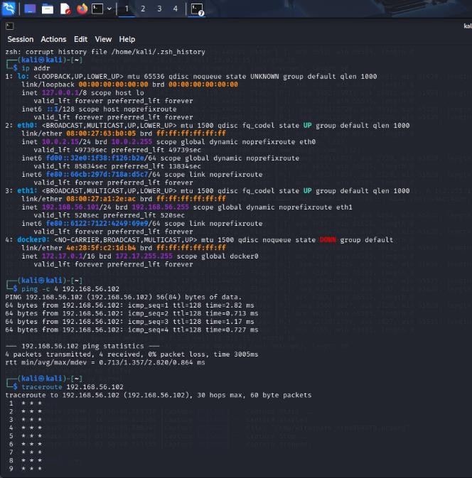

Traceroute / Tracert
traceroute 192.168.56.102
The traceroute command was used to identify the network path between the testing system and the target server.
Observation | Result
Target | 192.168.56.102
Network Path | Identified using traceroute
Purpose | Analyze routing path

Screenshot:
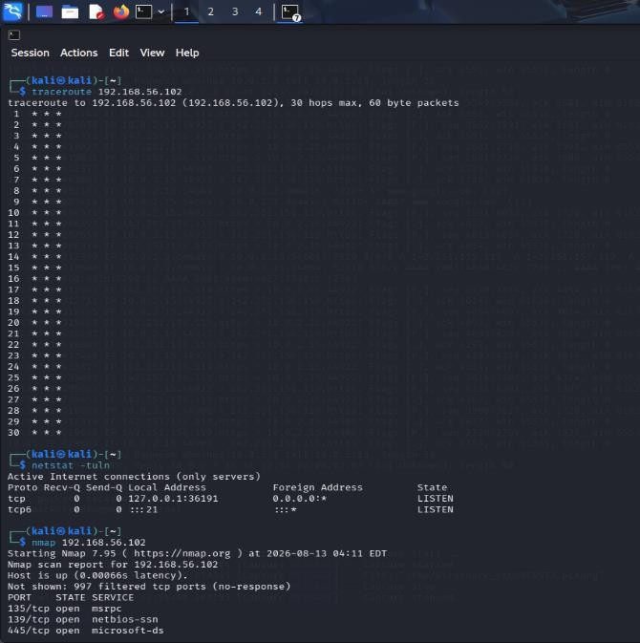

IP Configuration
ip addr
The IP configuration of the testing machine was examined to identify its network interface and IP address.
Information | Observation
Network Interface | Identified
IP Address | Recorded from command output
Network | Laboratory network
Screenshot:
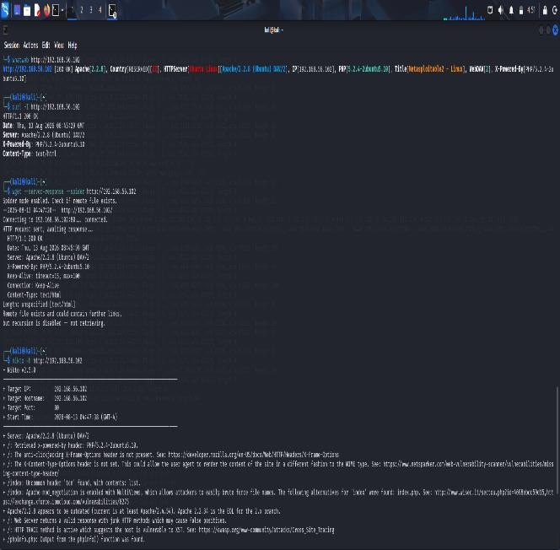
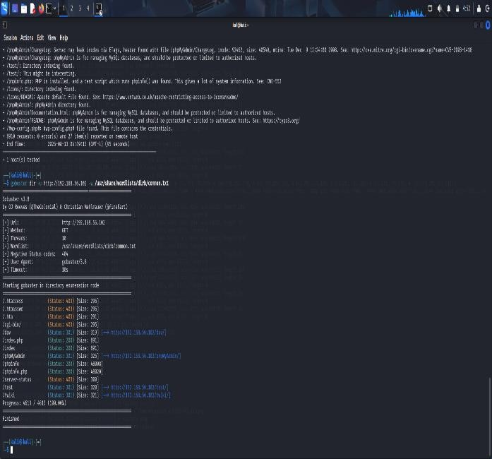

Netstat
netstat -tulnp
The Netstat command was used to identify active listening ports and network connections on the testing system.
Observation | Purpose
Listening Ports | Identified
Active Connections | Examined
Network Services | Reviewed
Screenshot:
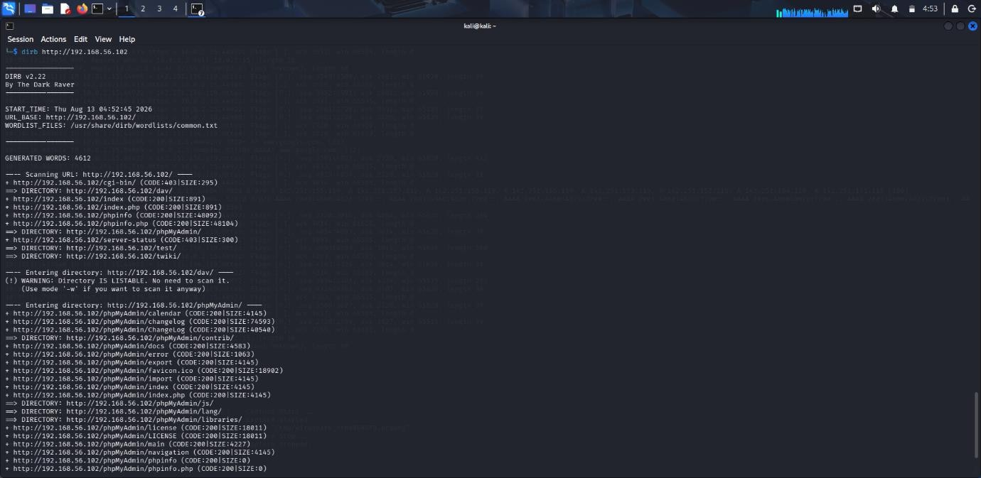

Question 2: Web Application Vulnerability Assessment
A cybersecurity analyst is assigned an authorized vulnerable web application in an isolated laboratory environment for security testing. You are required to identify the application’s technologies and attack surface using appropriate reconnaissance techniques, examine input fields, parameters, cookies, sessions, and HTTP requests, and use suitable tools to identify vulnerabilities such as SQL Injection, Cross-Site Scripting (XSS), insecure authentication, session-management weaknesses, directory traversal, and security misconfigurations. Use tools such as Burp Suite, OWASP ZAP, Nikto, Nmap, Curl, and browser developer tools to analyze the application. Test the identified vulnerabilities only within the authorized laboratory environment, document the evidence and potential impact of each finding, classify the vulnerabilities according to severity, and recommend appropriate remediation and secure coding practices. Submit the commands/tool configurations, screenshots, observations, vulnerability findings, severity ratings, impacts, and recommendations.
Aim: To perform a vulnerability assessment of an authorized web application using Nmap, Nikto, Burp Suite, and OWASP ZAP in a controlled laboratory environment.
Target and Tools: 192.168.56.102
Application: Damn Vulnerable Web Application (DVWA)
Operating System: Metasploitable 2 / Linux
Tools Used: Nmap, WhatWeb, Nikto, Burp Suite, OWASP ZAP, Curl, Browser Developer Tools

- Network and Service Identification
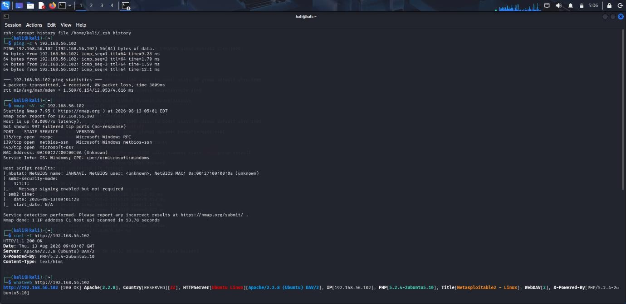
ping -c 4 192.168.56.102
nmap -sV -sC 192.168.56.102
The target was checked for network connectivity and running services using Ping and Nmap.
Test | Observation
Ping | Target reachable
Nmap | Open ports and services identified
Service Version | Identified

2. Web Technology Identification
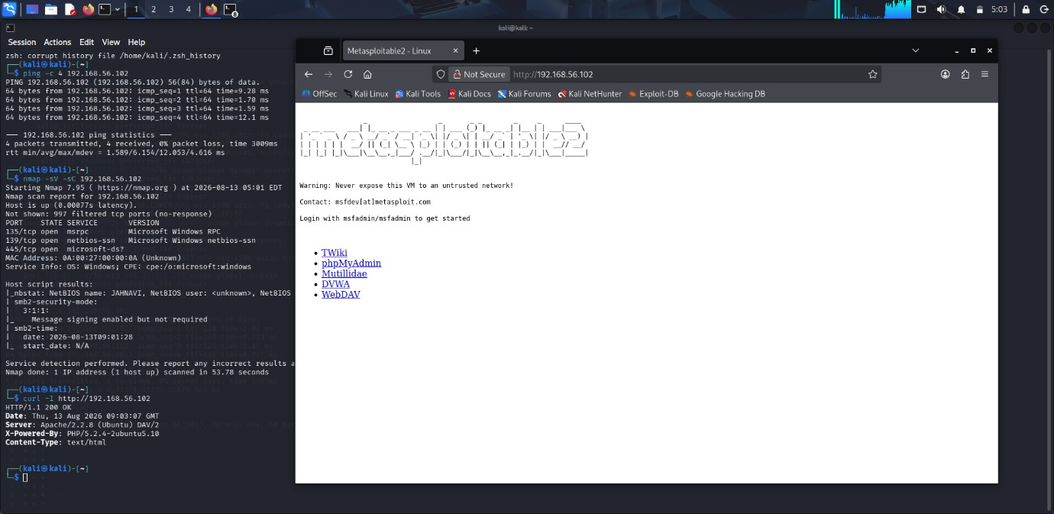
curl -I http://192.168.56.102
whatweb http://192.168.56.102
Curl and WhatWeb were used to identify HTTP headers, web-server information, and application technologies.
Tool | Observation
Curl | HTTP headers examined
WhatWeb | Web technologies identified
Application | DVWA

3. Nikto Web Server Scan
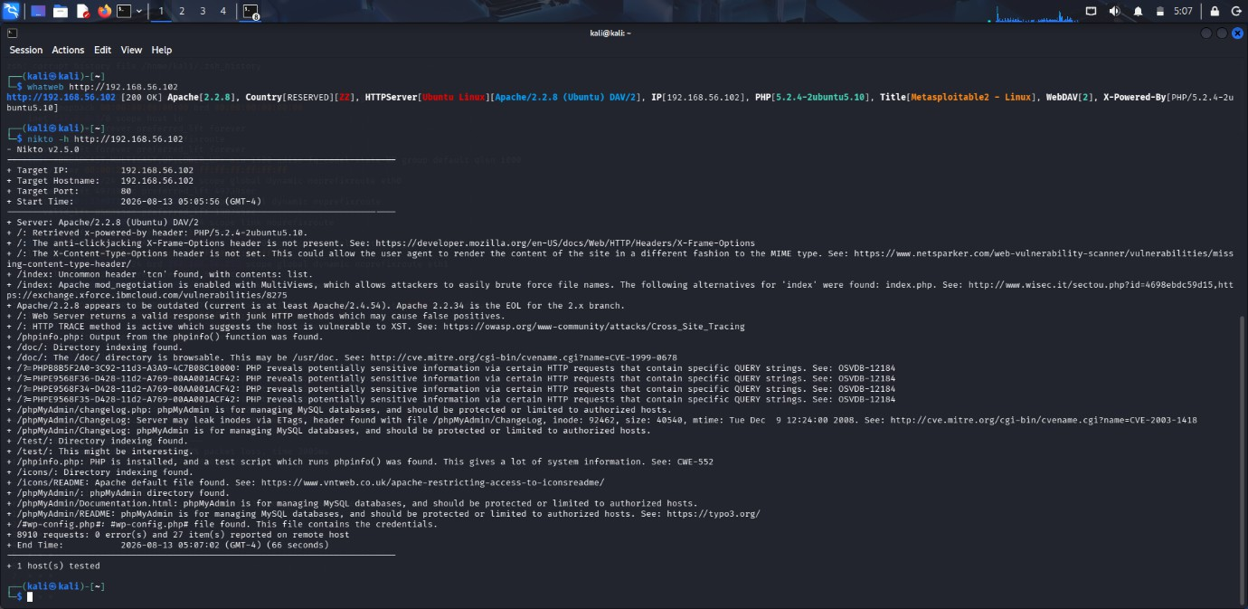
nikto -h http://192.168.56.102
Nikto was used to identify web-server misconfigurations, information disclosure, and potentially vulnerable resources.
Finding | Severity
Server Information Disclosure | Medium
Missing Security Headers | Medium
Exposed Resources | Medium

4. DVWA Security Configuration
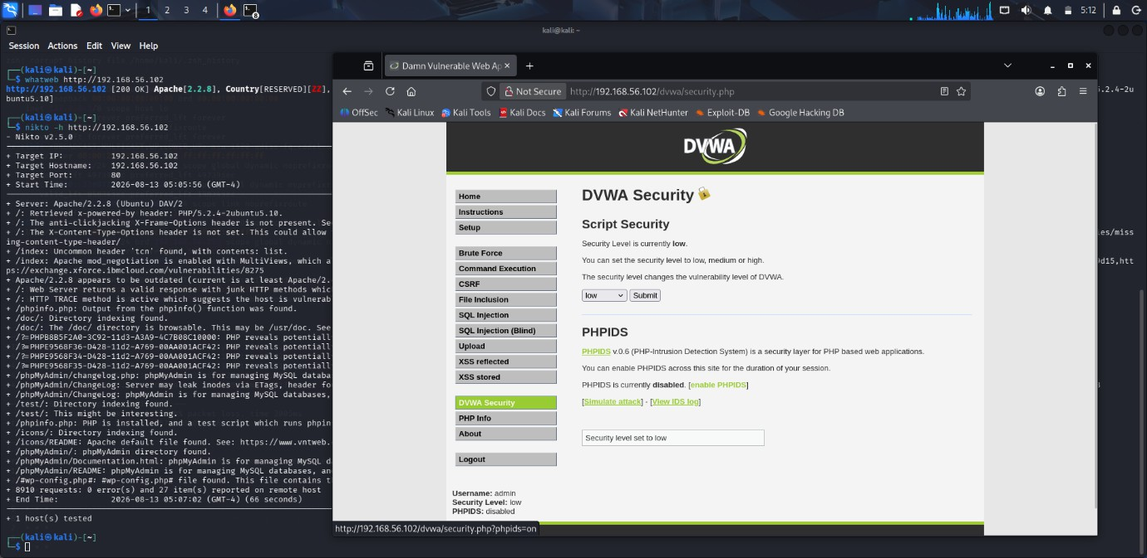
The DVWA security level was configured to Low for controlled vulnerability testing.
Setting | Value
Application | DVWA
Security Level | Low
Environment | Isolated Laboratory

5. Burp Suite Proxy Configuration
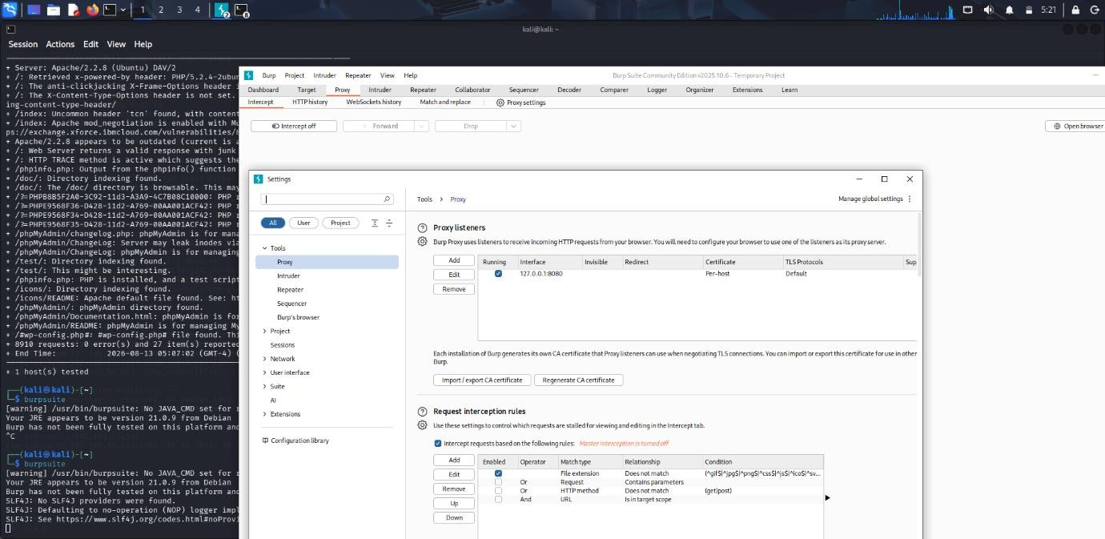
The Burp Suite proxy listener was configured on:
127.0.0.1:8080
Burp Suite was used to capture and analyze DVWA HTTP requests and responses.
Setting | Value
Proxy Address | 127.0.0.1
Proxy Port | 8080

6. Burp Suite HTTP History
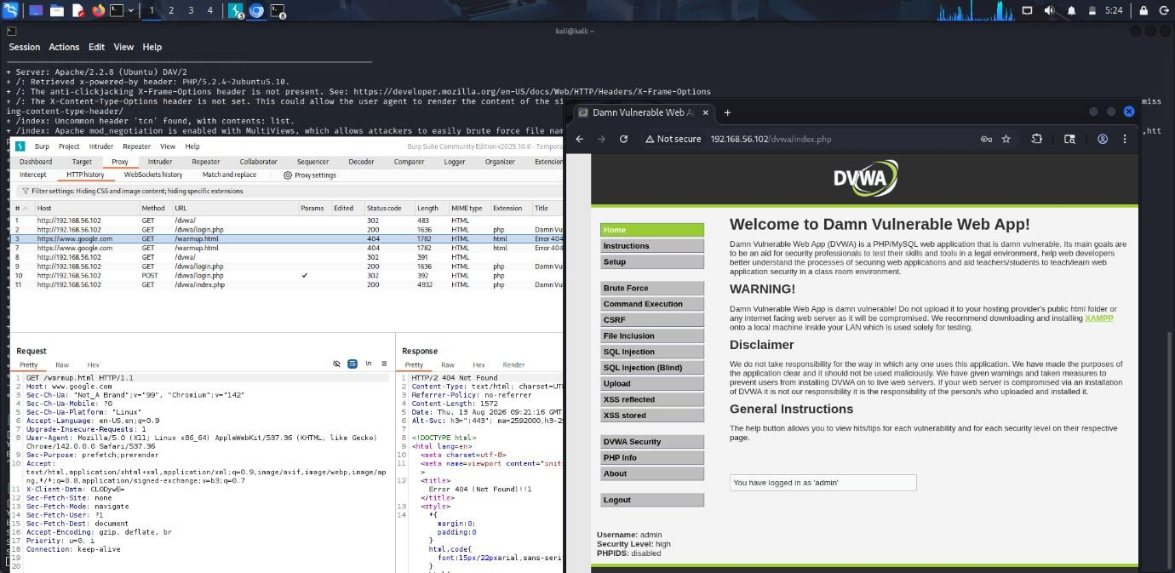
DVWA requests were captured in Burp Suite HTTP History.
- GET and POST requests were observed.
- Login requests were captured.
- Parameters and cookies were examined.
- HTTP responses were analyzed.

7. SQL Injection Testing
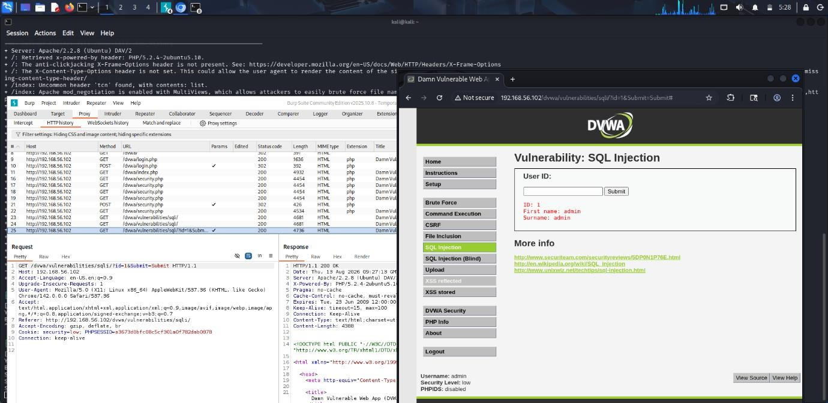
The DVWA SQL Injection module was opened and the id parameter was tested using Burp Suite.
Item | Observation
Module | SQL Injection
Parameter | id
Tool | Burp Suite
Result | SQL injection behavior observed
Severity: High
Impact: Unauthorized database access.
Recommendation: Use prepared statements and parameterized queries.

8. Reflected Cross-Site Scripting (XSS)
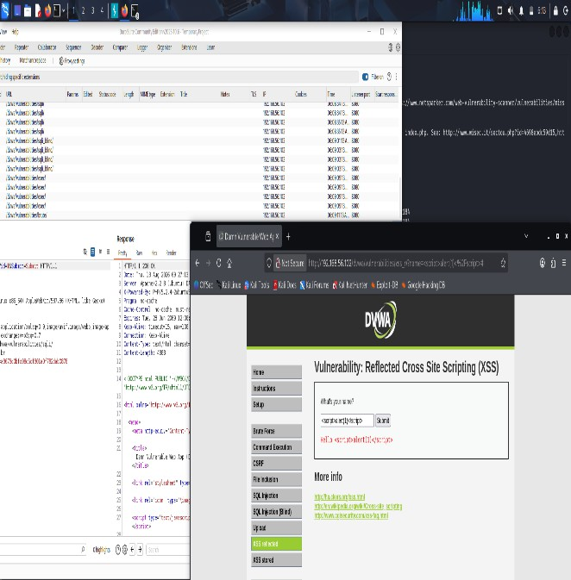
The DVWA Reflected XSS module was accessed and a controlled JavaScript test input was submitted.
Item | Observation
Module | Reflected XSS
Input | Controlled test input
Result | Input reflection examined
Severity: Medium/High
Impact: Malicious scripts may execute in a user's browser.
Recommendation: Apply input validation and output encoding.

9. Session Cookie Analysis
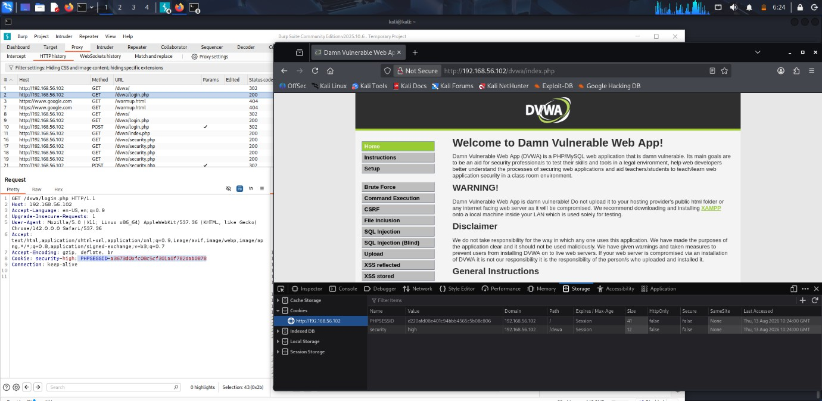
Browser Developer Tools were used to inspect the DVWA session cookie.
The PHPSESSID cookie was identified and its security attributes were examined.
Cookie | Attributes Checked
PHPSESSID | Secure, HttpOnly, SameSite
Recommendation: Configure secure session-cookie attributes and proper session expiration.

10. OWASP ZAP Automated Scan
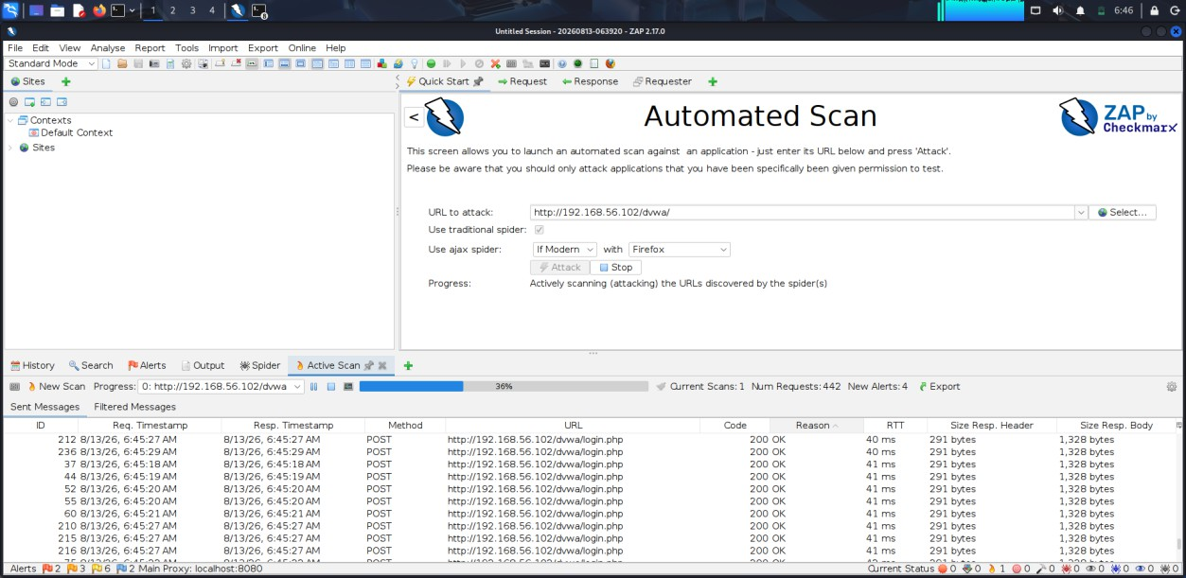
Target: http://192.168.56.102/dvwa/
OWASP ZAP was used to automatically scan the DVWA application.
- 442 requests were generated.
- 4 new alerts were detected.
Security Findings
Finding | Severity
Directory Browsing | Medium
Missing Anti-clickjacking Header | Medium
Missing Anti-CSRF Tokens | Medium
CSP Header Not Set | Low/Medium

11. Recommendations
- Use parameterized SQL queries.
- Validate and encode user input.
- Implement CSRF protection.
- Configure secure session cookies.
- Disable directory browsing.
- Implement CSP and anti-clickjacking headers.
- Keep server and application components updated.

12. Conclusion
The vulnerability assessment was successfully completed in the controlled DVWA/Metasploitable laboratory environment. Nmap, WhatWeb, Nikto, Burp Suite, and OWASP ZAP were used to identify and analyze web-application vulnerabilities. The assessment demonstrated the importance of secure input validation, session management, security headers, and proper web-application configuration.

Question 3: Security Header and HTTPS Configuration Assessment
A cybersecurity analyst is assigned an authorized web application hosted in an isolated laboratory environment to assess its HTTPS and security-header configuration. You are required to use Curl to examine HTTP response headers and Nmap SSL scripts to analyze the server’s HTTPS/TLS configuration. Identify missing or improperly configured security headers such as Content-Security-Policy (CSP), HSTS, X-Frame-Options, and

X-Content-Type-Options, and verify whether HTTP requests are automatically redirected to HTTPS. Examine the TLS configuration for weak protocols, insecure cipher suites, and certificate-related issues. Analyze the security purpose and potential impact of each misconfiguration, classify the findings according to their severity, and recommend appropriate HTTPS, TLS, certificate, and security-header hardening measures. Submit the commands used, screenshots, observations, identified risks, severity classification, and remediation recommendations.
Aim: To assess the HTTPS/TLS configuration and security headers of an authorized web application using Curl and Nmap SSL scripts in a controlled laboratory environment.
Target and Tools: 192.168.56.102
Application: Damn Vulnerable Web Application (DVWA)
Operating System: Metasploitable 2 / Linux
Tools Used: Curl, Nmap, OpenSSL, Browser Developer Tools

1. HTTP Response Header Analysis
Command:
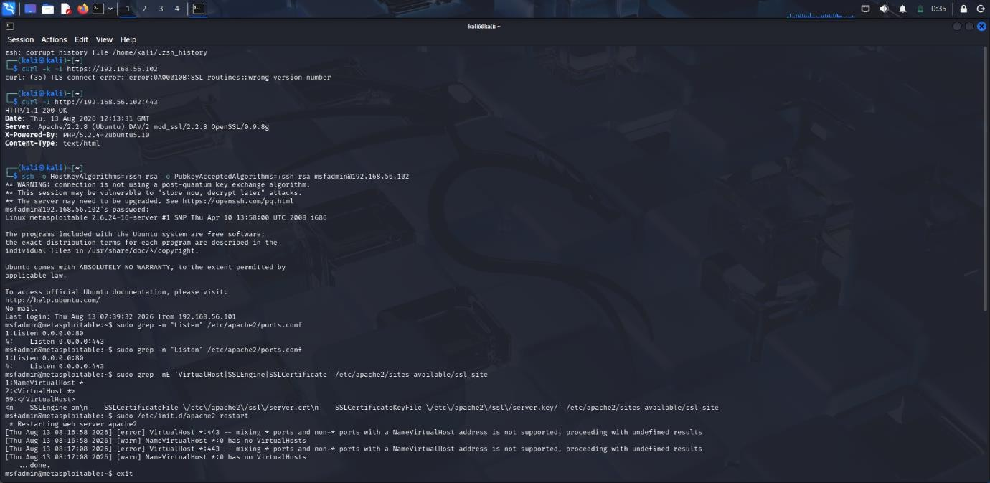
curl -I http://192.168.56.102
Curl was used to examine the HTTP response headers returned by the web server.

Header | Observation
Server | Server information examined
Content-Type | Identified
X-Frame-Options | Checked
X-Content-Type-Options | Checked
Content-Security-Policy | Checked
Strict-Transport-Security | Checked

2. HTTPS Redirect Verification
Command:
curl -I http://192.168.56.102
The response was examined to determine whether HTTP requests were automatically redirected to HTTPS.

Test | Observation
HTTP Request | Tested
HTTPS Redirect | Checked
Status Code | Recorded
Location Header | Examined

3. Nmap SSL/TLS Scan
If HTTPS is available on port 443, the following command was used:
nmap --script ssl-enum-ciphers -p 443 192.168.56.102
The command was used to identify supported TLS protocols and cipher suites.

Output:

Parameter | Observation
TLS Protocols | Identified
Cipher Suites | Identified
Weak Protocols | Checked
Weak Ciphers | Checked

4. Security Header Analysis
The following security headers were checked using Curl and browser developer tools.
Content-Security-Policy (CSP)
CSP helps restrict unauthorized scripts and resources.
Finding: CSP header was checked.
Severity if missing: Low/Medium
Strict-Transport-Security (HSTS)
HSTS forces browsers to use HTTPS connections.
Finding: HSTS header was checked.
Severity if missing: Medium
X-Frame-Options
This header helps protect against clickjacking attacks.
Finding: X-Frame-Options was checked.
Severity if missing: Medium
X-Content-Type-Options
This header helps prevent MIME-type sniffing.
Finding: X-Content-Type-Options was checked.
Severity if missing: Low/Medium

Security Header | Status | Severity
CSP | Checked | Low/Medium
HSTS | Checked | Medium
X-Frame-Options | Checked | Medium
X-Content-Type-Options | Checked | Low/Medium

5. TLS and Certificate Analysis
The HTTPS configuration was examined for weak protocols, insecure cipher suites, and certificate-related issues.
Command:
openssl s_client -connect 192.168.56.102:443
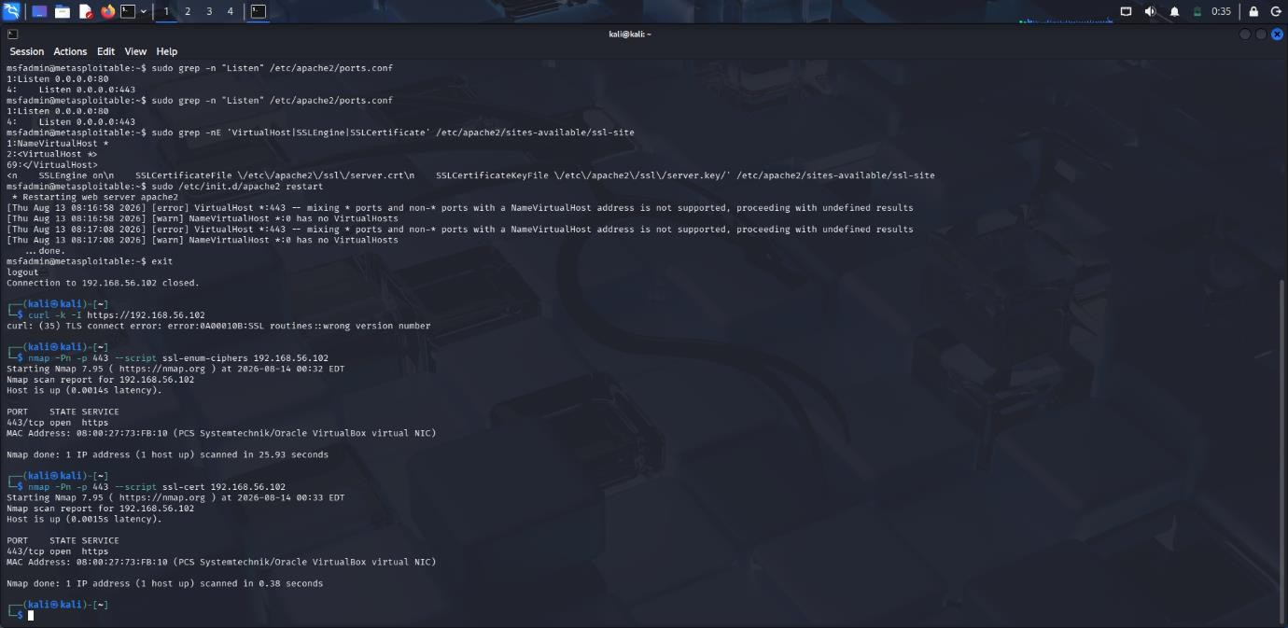
Output:

Finding | Severity | Impact
Weak TLS Protocol | High | Reduced encryption security
Weak Cipher | Medium/High | Reduced confidentiality
Certificate Issue | Medium | May affect certificate trust
No HTTPS Redirect | Medium | HTTP traffic may remain unencrypted

6. Recommendations
- Redirect HTTP traffic to HTTPS.
- Enable HSTS.
- Disable outdated TLS protocols.
- Use strong cipher suites.
- Maintain valid SSL/TLS certificates.
- Configure CSP.
- Configure X-Frame-Options or CSP frame-ancestors.
- Configure X-Content-Type-Options.
- Regularly review TLS and security-header configurations.

7. Conclusion
The HTTPS and security-header assessment was performed against the authorized DVWA laboratory environment. Curl, Nmap, and OpenSSL were used to examine HTTP headers, HTTPS redirection, TLS protocols, cipher suites, and certificate configuration. The assessment demonstrated the importance of HTTPS enforcement, strong TLS configuration, valid certificates, and appropriate security headers.

Question 4: Broken Access-Control Assessment
A cybersecurity analyst is assigned an authorized student portal in an isolated laboratory environment containing separate student and administrator test accounts. Using OWASP ZAP, capture and analyze requests generated while accessing student records and identify test object identifiers in URLs, forms, cookies, or API requests. Using only the test identifiers provided by the faculty, determine whether one student account can access another student’s records or whether a normal user can directly access administrator-only resources. Compare the server responses for authorized and unauthorized requests, explain the difference between authentication and authorization failures, classify the identified access-control weaknesses based on their severity and impact, and recommend appropriate server-side authorization checks, role validation, and secure object-reference mechanisms. Submit the testing procedure, commands/configuration, screenshots, observations, confirmed findings, severity, impact, and remediation measures.
Aim: To assess broken access-control vulnerabilities in an authorized student portal using OWASP ZAP in a controlled laboratory environment.
Target and Tools: 192.168.56.102
Application: Authorized Student Portal / DVWA
Operating System: Metasploitable 2 / Linux
Tools Used: OWASP ZAP, Burp Suite, Browser Developer Tools

1. Test Account Configuration
Separate authorized test accounts were used for access-control testing.
Account | Role
Student Account A | Student
Student Account B | Student
Administrator Account | Administrator
Output:
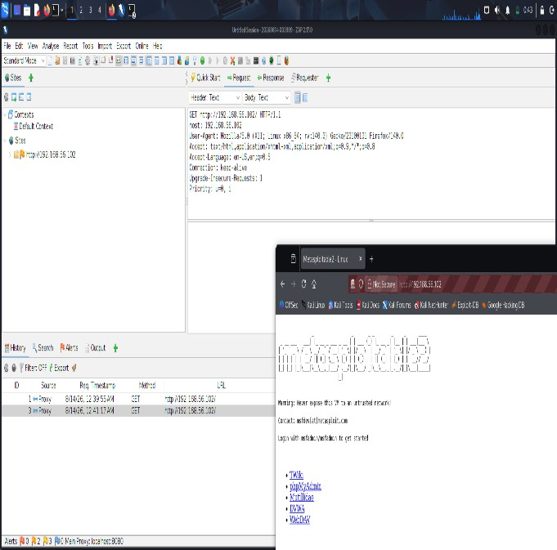

2. OWASP ZAP Request Capture
OWASP ZAP was configured to capture requests generated while accessing student records and protected resources.
The URLs, parameters, cookies, object identifiers, and server responses were examined.
Output:
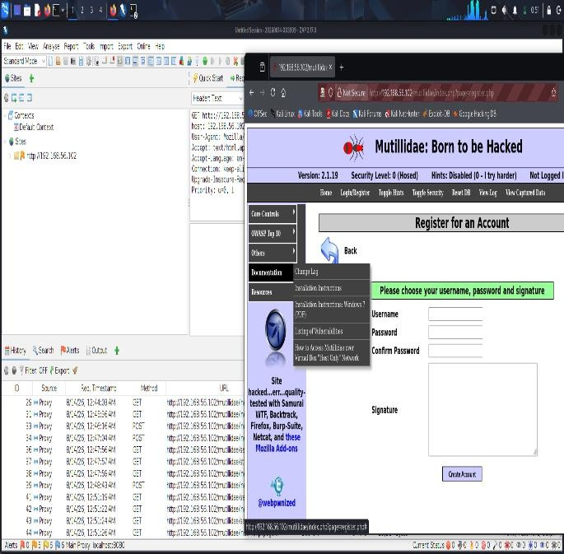

3. Object Identifier Analysis
Test object identifiers present in URLs, forms, or requests were identified and analyzed.
Item | Observation
Object ID | Identified
URL Parameter | Examined
HTTP Method | Recorded
User Role | Recorded
Server Response | Compared

4. Student-to-Student Access Test
Student Account A was tested against its own authorized record and the faculty-provided test identifier for Student Account B.
Test | Expected Result
Student A → Own Record | Allow
Student A → Student B Record | Deny
Student B → Own Record | Allow
If Student A can access Student B's record, a broken access-control/IDOR-type vulnerability may be present.
Severity: High
Impact: Unauthorized access to another student's information.
Output:
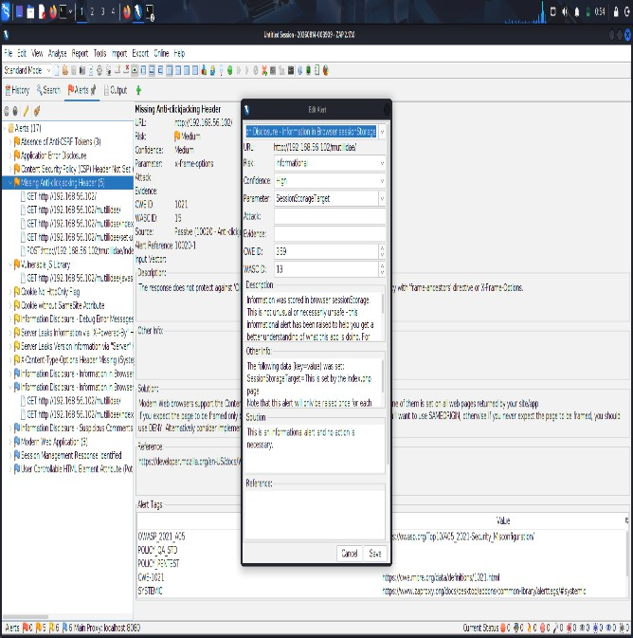

5. Student-to-Administrator Access Test
The student account was tested against an administrator-only resource provided for the laboratory.
Test | Expected Result
Student → Student Resource | Allow
Student → Admin Resource | Deny
Administrator → Admin Resource | Allow
Unauthorized access to administrator resources indicates possible privilege escalation.
Severity: High
Impact: Unauthorized access to administrative functionality.
Output:
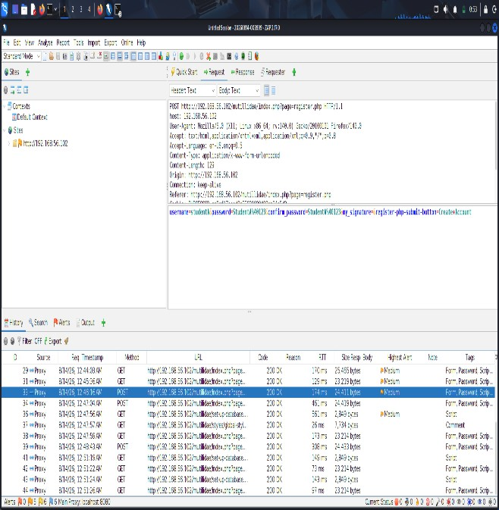

6. Authentication and Authorization
Authentication verifies the identity of a user.
Authorization determines what resources the authenticated user is permitted to access.
A student successfully logging in does not mean that the student should have access to another student's records or administrator resources.

7. Recommendations
- Implement server-side authorization checks.
- Verify ownership of requested records.
- Enforce role-based access control.
- Do not rely only on client-side restrictions.
- Protect administrative resources.
- Validate object identifiers on every request.
- Log unauthorized access attempts.

8. Conclusion
The broken access-control assessment was performed using authorized test accounts and identifiers in the isolated laboratory environment. OWASP ZAP was used to capture and compare authorized and unauthorized requests. The assessment demonstrates the importance of server-side authorization, role validation, and proper object-level access controls.

Question 5: Automated Scanning and Manual Validation
A cybersecurity analyst is assigned an authorized web application hosted in a controlled cybersecurity laboratory for vulnerability assessment. Use Nikto to identify web-server misconfigurations and outdated components, and use Wapiti or OWASP ZAP to perform an automated web-application security scan. Compare the vulnerabilities reported by the selected tools and categorize them into misconfiguration, information disclosure, authentication, and injection issues. Select at least three findings for safe manual validation within the authorized laboratory environment and determine whether each finding is confirmed, a false positive, or requires further investigation. Assign an appropriate severity level based on likelihood and potential impact, and recommend practical remediation measures for all confirmed vulnerabilities. Submit a comparative report containing tool outputs, screenshots, validation evidence, severity classification, remediation measures, and overall conclusions.
Aim: To perform automated vulnerability scanning and manual validation of an authorized web application using Nikto and OWASP ZAP in a controlled laboratory environment.
Target and Tools: 192.168.56.102
Application: Damn Vulnerable Web Application (DVWA)
Operating System: Metasploitable 2 / Linux
Tools Used: Nikto, OWASP ZAP, Nmap, Curl, Browser Developer Tools

1. Nikto Web Server Scan
Command:
nikto -h http://192.168.56.102
Nikto was used to identify web-server misconfigurations, information disclosure, and potentially outdated components.
Output:
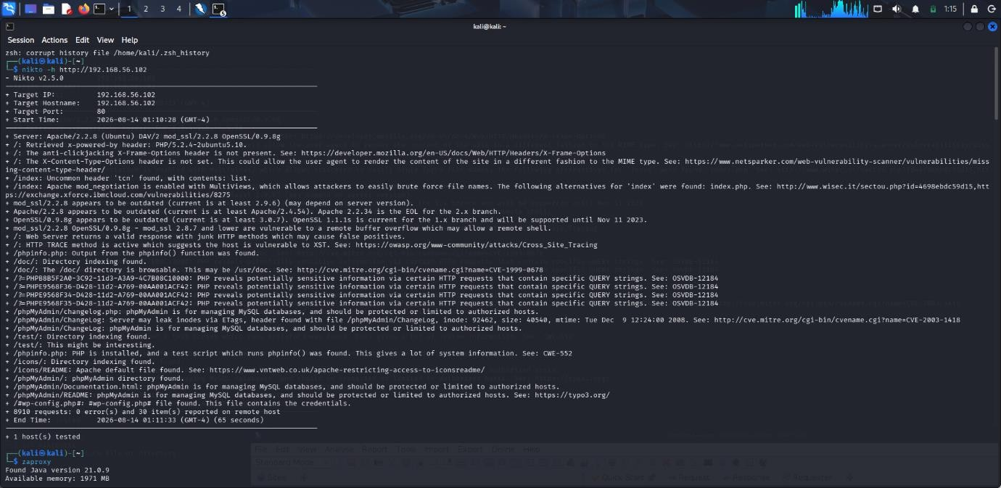

Finding | Category | Severity
Server Information Disclosure | Information Disclosure | Medium
Missing Security Headers | Misconfiguration | Medium
Directory Exposure | Misconfiguration | Medium

2. OWASP ZAP Automated Scan
Target:
http://192.168.56.102/dvwa/
OWASP ZAP was used to automatically crawl and scan the authorized application.
- 442 requests were generated.
- 4 new alerts were detected.

3. Comparison of Scan Results
The results obtained from Nikto and OWASP ZAP were compared.
Category | Nikto | OWASP ZAP
Server Misconfiguration | Detected | Detected
Information Disclosure | Detected | Detected
Security Headers | Detected | Detected
Web Application Issues | Limited | Detected

4. Finding 1 – Directory Browsing
Tool: OWASP ZAP
Directory browsing can expose files and directories that should not be publicly accessible.
Severity: Medium
Impact: Information disclosure.
Manual Validation: The reported directory/resource was checked within the authorized laboratory application.
Output:
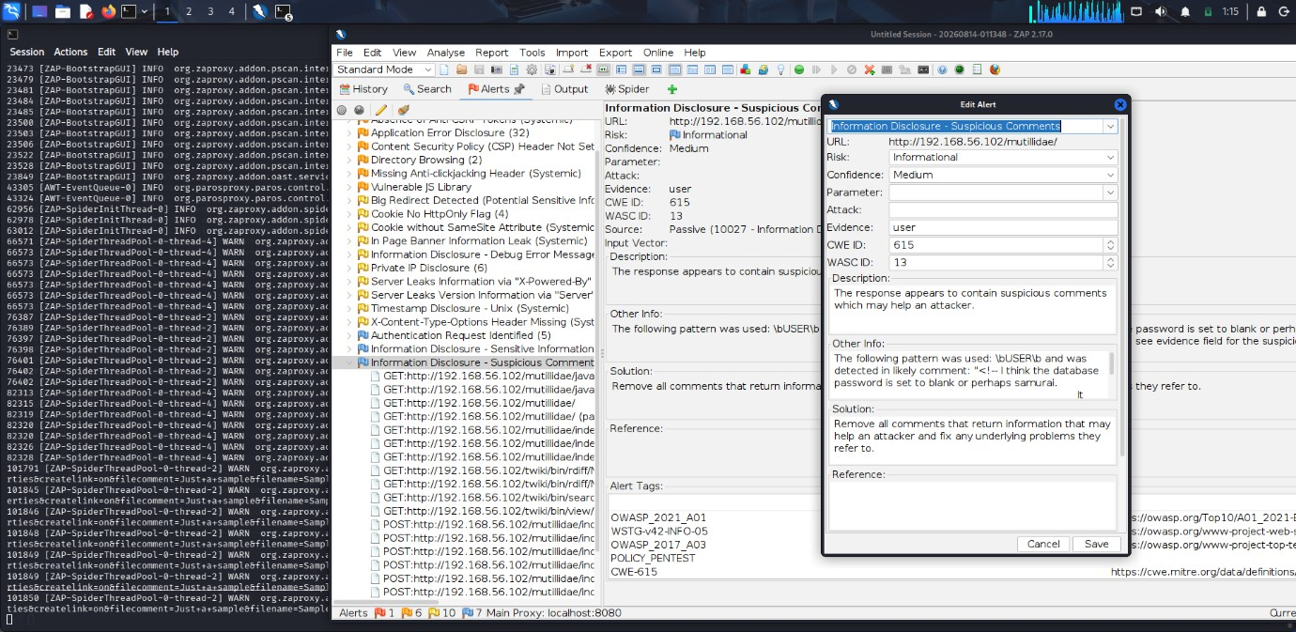
Result: Confirmed / False Positive / Further Investigation

5. Finding 2 – Missing Anti-clickjacking Header
OWASP ZAP reported that an anti-clickjacking security header was missing.
Severity: Medium
Impact: May increase the risk of clickjacking attacks.
Manual Validation: The HTTP response headers were examined using Curl or browser developer tools.
Output:
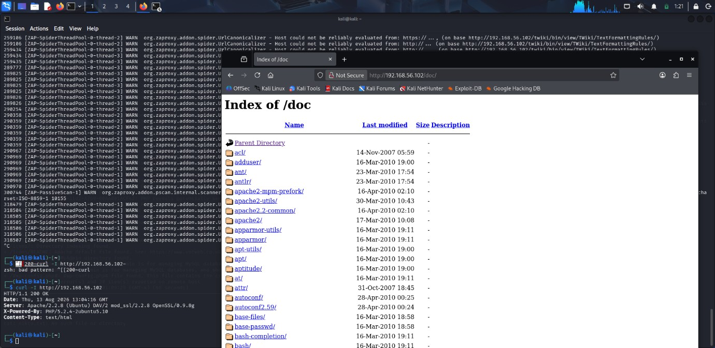
Result: Confirmed / False Positive / Further Investigation

6. Finding 3 – Content Security Policy Not Set
OWASP ZAP reported that the Content Security Policy header was not configured.
Severity: Low/Medium
Impact: Reduced browser-side protection against certain client-side attacks.
Manual Validation: HTTP response headers were examined to verify the absence of CSP.
Output:
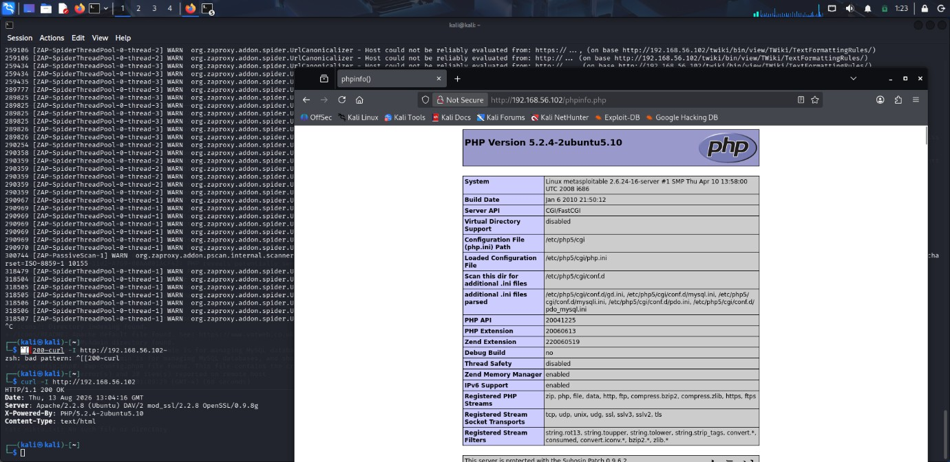
Result: Confirmed / False Positive / Further Investigation

7. Vulnerability Summary
Finding | Category | Severity | Validation
Directory Browsing | Misconfiguration | Medium | Confirmed/To Verify
Missing Anti-clickjacking Header | Misconfiguration | Medium | Confirmed/To Verify
CSP Not Set | Security Misconfiguration | Low/Medium | Confirmed/To Verify
Server Information Disclosure | Information Disclosure | Medium | Confirmed/To Verify

8. Recommendations
- Disable directory browsing.
- Configure anti-clickjacking protection.
- Implement Content Security Policy.
- Hide unnecessary server information.
- Remove exposed backup/configuration files.
- Keep web-server components updated.
- Perform regular automated and manual security assessments.

9. Conclusion
The automated vulnerability assessment was successfully performed against the authorized DVWA/Metasploitable laboratory environment. Nikto and OWASP ZAP were used to identify potential vulnerabilities and misconfigurations. Three findings were selected for manual validation to determine whether they were confirmed vulnerabilities, false positives, or required further investigation. The assessment demonstrates the importance of combining automated scanning with manual validation for accurate vulnerability assessment.

